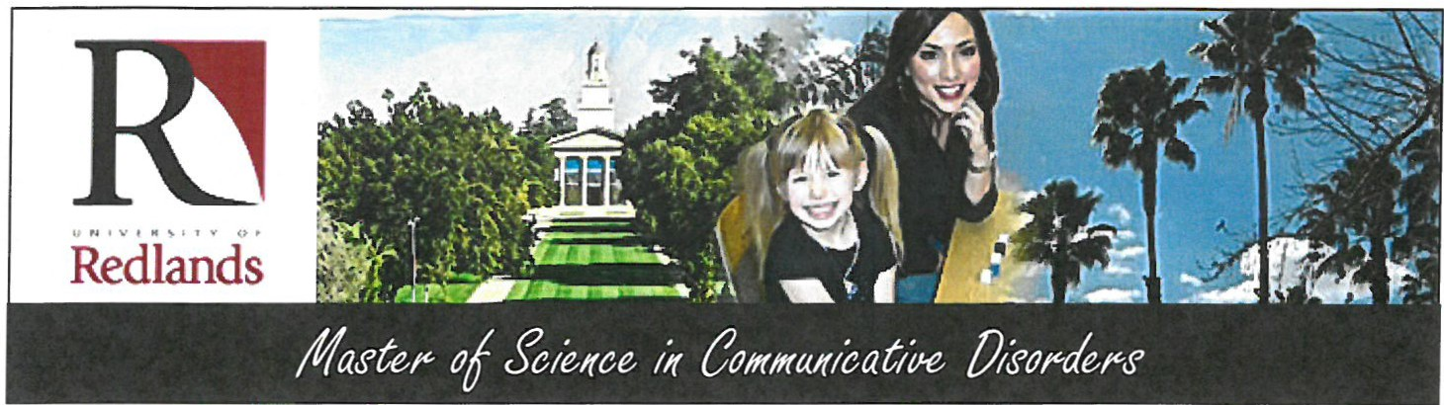

Prepare for your Future:
At University of Redlands, our graduate program is one of the leading professional training programs in the country. We provide a caring and personal
atmosphere where students and faculty work together . At the end of our two year program, you will earn the California State license, California Speech Language Pathologist Services Credential (SLPS), and ASHA certification (CCCs).

Learn with the Best:
Our faculty members greet new students with gracious warmth that is perhaps indicative of their chosen profession, training students to become dedicated professionals in a field that helps those with disorders live in a world heavily reliant on quick and clear communication. They are equally dedicated to preserving the success of this nationally recognized graduate program.

Enjoy the Experience:
It is easy to feel at home at the Truesdail Center for Communication Sciences and Disorders. Not only will you collaborate with faculty, but also with your student peers, creating relationships that will last a lifetime

Career Outlook:

Speech- language pathology is expected to grow faster than average through the year 2018.

Prepare now for a rewarding career as a speech-language pathologist.

According to the Bureau of Labor Statistics, the Med1an annual wage of a speech-language patholog1st was
$62,930 in May 2008. The middle 50%

earned between $50,330 and $79,620. The lowest 10 percent earned less than
$41,240, and the highest 10% earned more than $99,220. Median annual earnings in the mdustries employing the largest numbers of speech -language pathologists were:

Here at University of Redlands, we have a
strong alumni connection. What better place than Redlands to study, where you can draw from a diverse southern California population and students from around the world. There is an undeniable energy with clients coming and going and students bouncing between our in-house clinic and the classroom. The environment is warm, friendly, and comfortable.

Nursing care facilities Home health care
services
General medical and
surgical hospitals
Offices of other health practitioners
Schools
$79,120

77,030

68,430

67,910

58,140

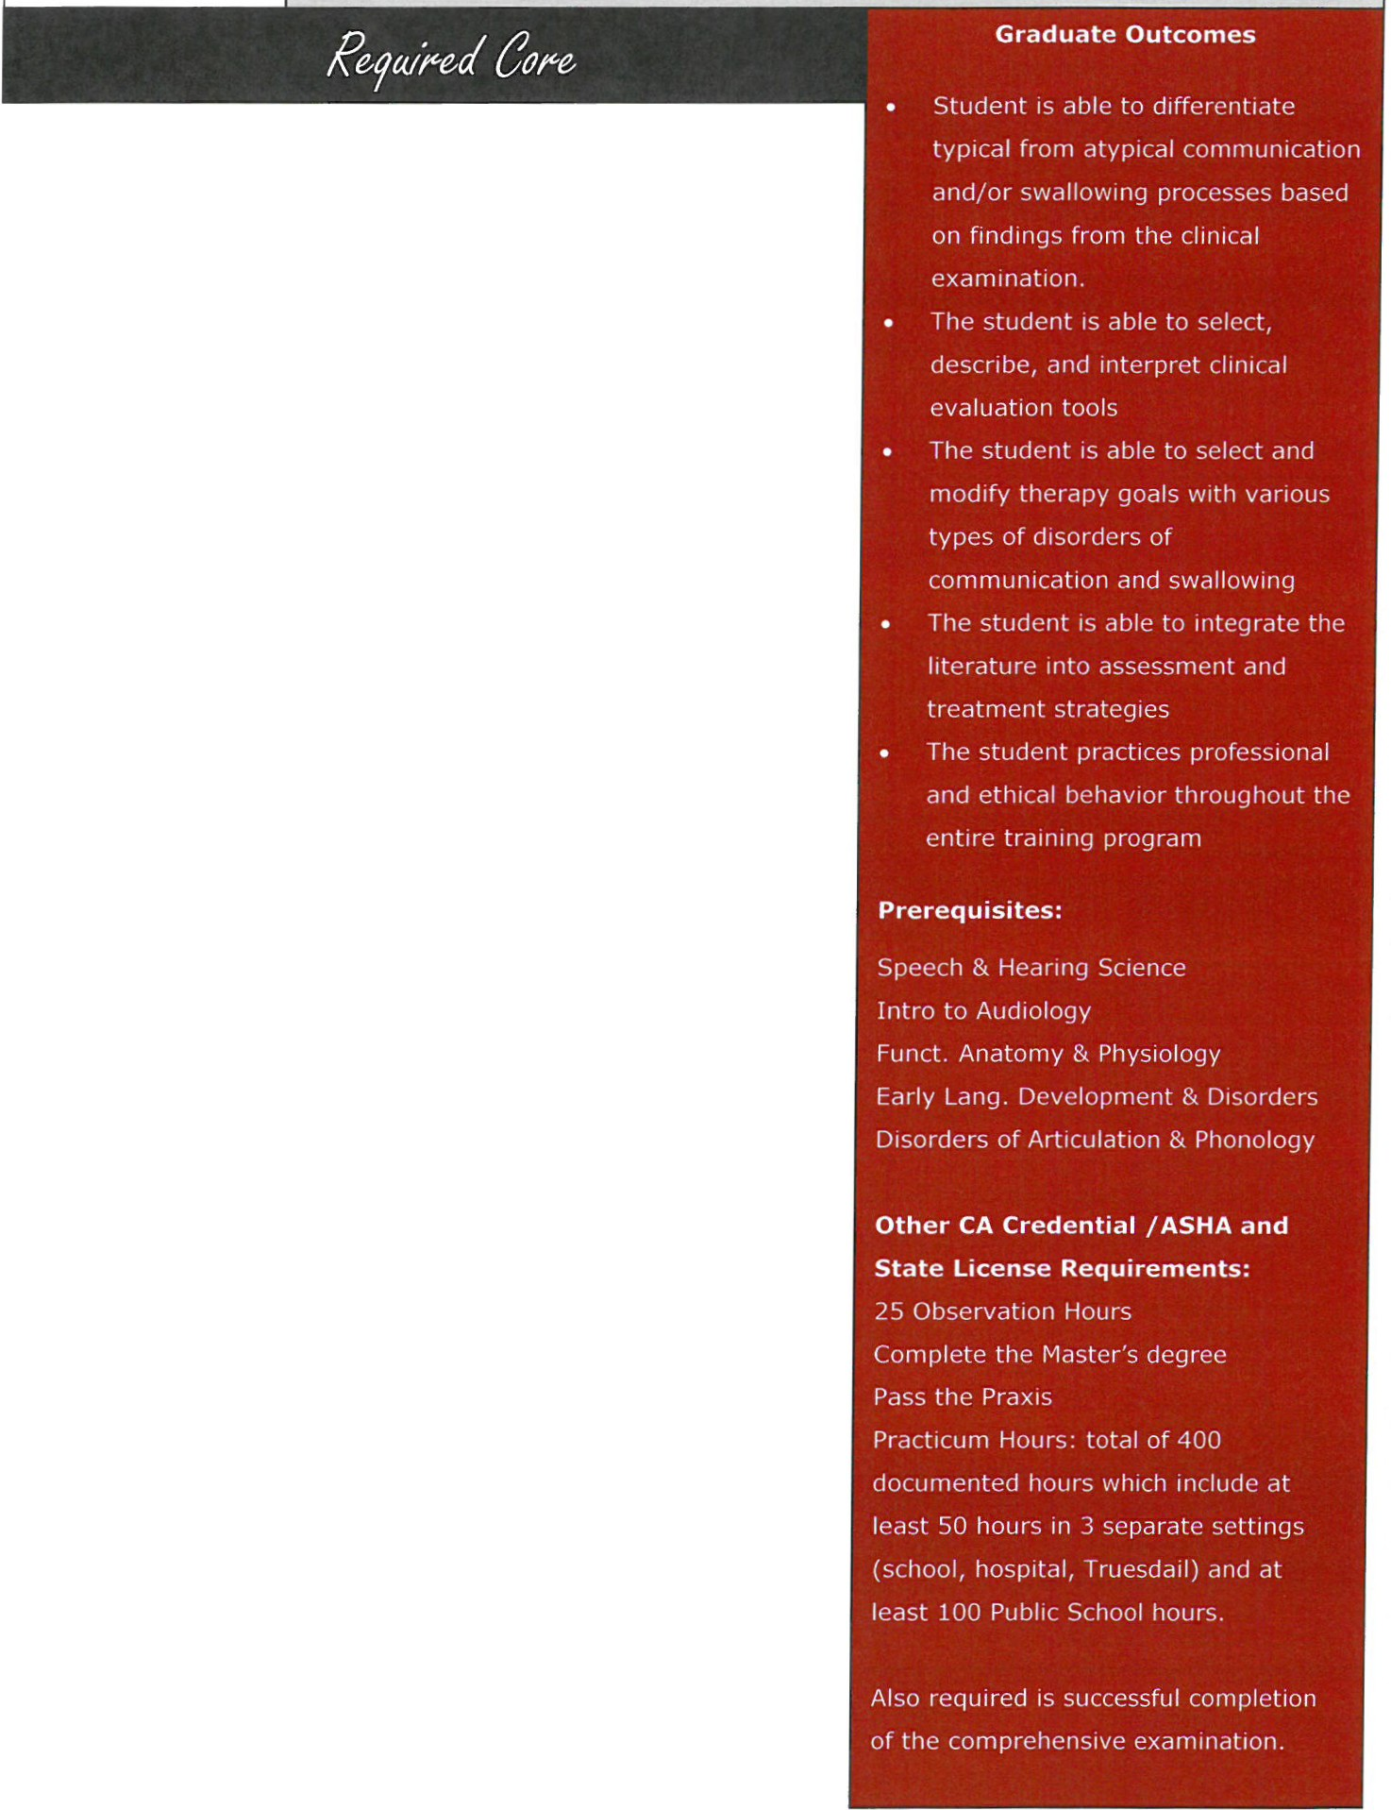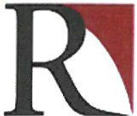

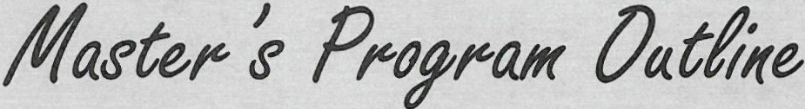Redlands

CDIS 615

CDIS 616

CDIS 619

CDIS 620

CDIS 622

CDIS 623

CDIS 626 CDIS 627* CDIS 629
CDIS 631 CDIS 634*

CDIS 647

CDIS 652

CDIS 655

CDIS 664

CDIS 683

CDIS 685
Neuropathologies of Speech, Language and Cognition Neuropathologies of Swallowing
Dev. & Disorders of Mono/Bilingual Spanish Speakers Seminar in CDIS: Language Pathology
Clinical Evaluation: Language & Learning Disorders

Assessment of Language Disorders in Children

Seminar in Articulation and Phonology Issues in Cultural and Linguistic Diversity Disorders of Fluency
Disorders of Voice

Theory & Practice in Clinical Evaluation: Speech and Language Pathology
Professional Methods

Research and Experimental Design

Advanced Aural Rehabilitation

Seminar in CDIS: Medical SLP/Counseling/ Autism

Spectrum Disorders/AAC Health-Based Externship
Public School Externship

All courses are 3 units each; a minimum of 60 units are required for the M.S. degree. For students with other backgrounds, there are 5 prerequisites (see column to the right).

Specialty Clinics: Enrollment in 6 clinics (2 units each) required
Adult Neurogenic Disorders

Child Speech Sound Disorders

Child Speech and Language Disorders Autism Spectrum Disorders
School-Age Language Disorders Early Language Disorders Fluency Disorders
Aural Rehabilitation

Disorders of Voice (optional extra clinic)

*627 or 619

*634 or 622

**Also required is successful completion of the comprehensive exam in the form of an oral case presentation.

