Esri User Conference In-Person Registration
Go to the Esri User Conference Registration page and click Register for in-person event.

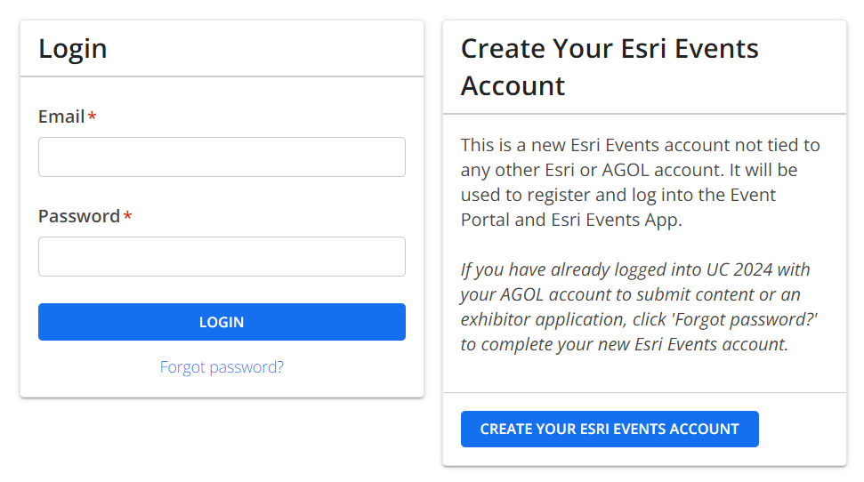

- Click on CREATE YOUR ESRI EVENTS ACCOUNT
- Fill out your name and email and set up a password. WRITE DOWN YOUR PASSWORD
- Click on ‘I am registering myself’, then click ‘Continue’

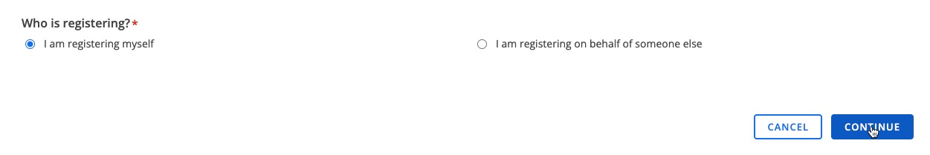

- Fill out your name, Redlands.edu email, address, etc. Use University of Redlands as the Organization. Click ‘Continue’.
- Using the drop down, choose ‘I want to enter in my customer number’.
- Use 12498 as our customer number.

- Click ‘Submit’
- Fill in your emergency contact information.
- For Organization type, choose Education.
- For Industry, choose Higher Education
- Choose your Functional Role
- Agree to the Communication Acknowledgment and Attendee Acknowledgement
- Select User Conference or UC + Industry Concurrent Events for ‘Which event are you interested in attending?’

  - Choose User Conference if you only plan to go to the UC.
  - Choose Industry Concurrent Events if you only plan to attend the Education Summit.
  - Choose UC and Industry Concurrent Events if you plan to attend both the UC and the Education Summit.
- Click ‘Continue’.

- On the next page, choose one or more of the following options.
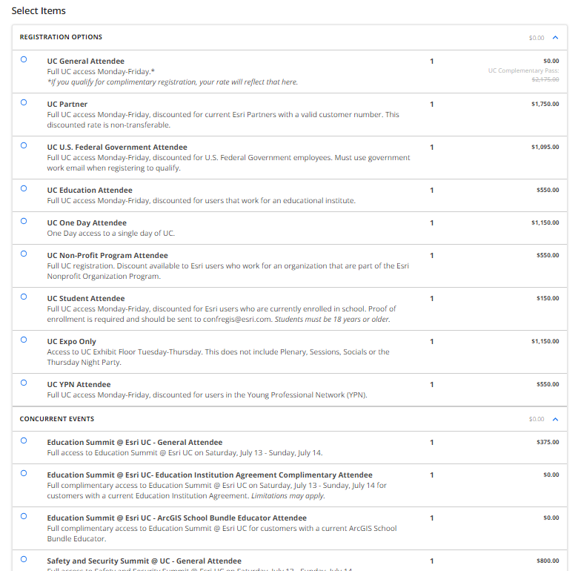

NOTE: Anyone who has registered for the in-person event will automatically receive digital access once it becomes available.

- At the bottom of the page, click Submit Order.
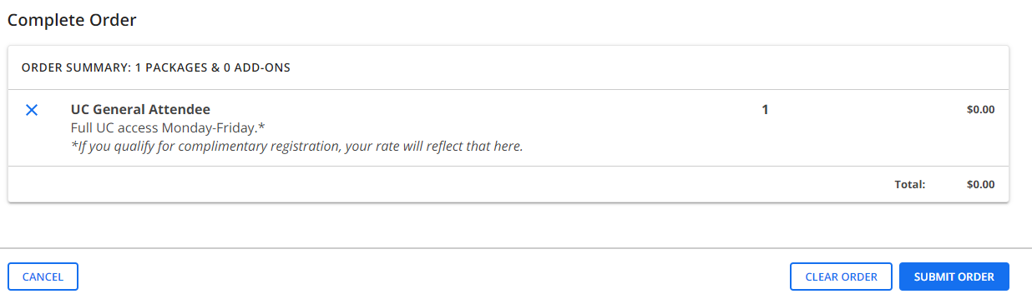

Within a few minutes, you should get a confirmation email from Esri. You can now checkout the adgenda and create your schedule.

If you encounter any difficulty registering, contact spatialstudies@redlands.edu.

See you at the show!

