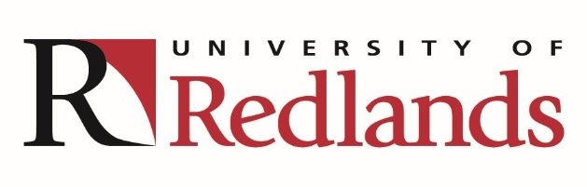

Truesdail Center for Communication Science and Disorders

Public Meeting

November 5, 2018, 4:30-5:30 PM
University of Redlands
Truesdail Center Room 115
(Corner of Sylvan Blvd. and University Street
Redlands, CA 92373

All interested parties are invited to participate in discussions regarding the Communication Sciences & Disorders Department (CDIS).
Who should attend?

- Students and alumni
- Clients and their families
- Employers of CDIS graduates
- Community partners
- Faculty and professionals in other disciplines
- All other interested persons

A copy of the Standards for Accreditation and/or the CAA’s Policy on Public Comment may be obtained by contacting the Accreditation Office at ASHA, 2200 Research Boulevard, #310, Rockville, Maryland 20850, calling ASHA’s Action Center at 1-800-498-2071, or accessing the documents online at http://caa.asha.org/.

Comments Submitted Prior to the Site Visit:
Individuals who wish to submit written testimony must adhere to the following: All written testimony - including comments faxed or submitted as e-mail attachments must include the commenter’s name, address and telephone contact information and the commenter’s relationship to the program in order for Accreditation staff to verify the source of the testimony. All comments must be signed.

Comments should be submitted to:

Accreditation Public Comment
Council on Academic Accreditation in Audiology and Speech-Language Pathology (CAA)
American Speech-Language-Hearing Association
2200 Research Boulevard, #310
Rockville, MD 20850
accreditation@asha.org
Fax: 301-296-8570

